Section A – Entity Relationship Diagram (ERD)
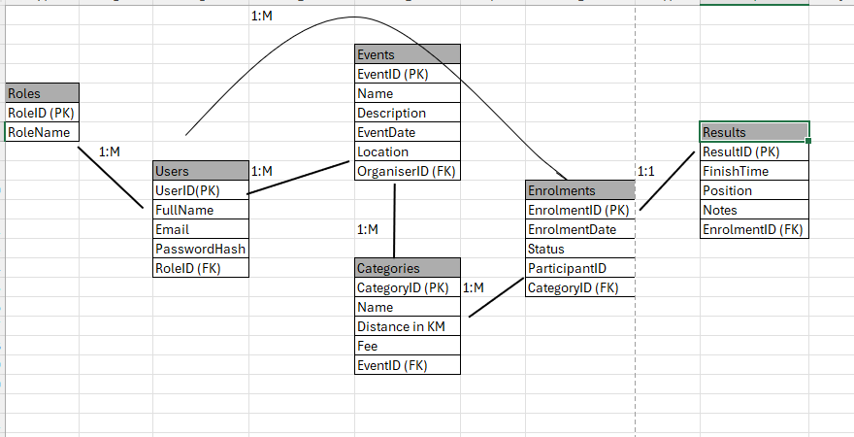
Section B – API Endpoint Plan

Authentication
HTTP Method | Route | Description | Role Required | Request Body | Expected Response
POST | /api/auth/register | Registers a new as an Organizer or Participant | None | { fullName, email, password, role} | 201 Created – new user id 400 Bad Request invalid/duplicate email
POST | /api/auth/login | Authenticated a user and returns a JWT token | None | { email, password} | 200 OK JWT token 401 Unauthorized invalid credentials

User Profile
HTTP Method | Route | Description | Role Required | Request Body | Expected Response
GET | /api/users/me | Returns the profile of the currently logged-in user | Any | None | 200 OK, user profile 401 Unauthorized
PUT | /api/users/me | Update the logged-in user’s own profile details | Any | {fullName, email } | 200 OK, updated profile 400 Bad Request

Events
HTTP Method | Route | Description | Role Required | Request Body | Expected Response
GET | /api/events | Lists all upcoming events | None | None | 200 OK, array of event
GET | /api/events/{id} | Gets full details for one event | None | None | 200 OK, event details 404 Not found
POST | /api/events | Create a new event | Organizer | { name, description, eventDate, location } | 201 Created – new event id 400 Bad Request
PUT | /api/event/{id} | Update an event the Organizer owns | Organizer | { name, description, eventDate, location} | 200 OK updated event 403 Forbidden 404 Not Found
DELETE | /api/events/{id} | Deletes an event the Organizers owns | Organizer | None | 204 No Content 403 Forbidden 404 Not Found

Categories
HTTP Method | Route | Description | Role Required | Request Body | Expected Response
GET | /api/events/{id}/categories | Lists all race categories for an event | None | None | 200 OK, array of categories
POST | /api/events/{id}/categories | Adds a new category to an event | Organizer | { name, distance in KM, fee} | 201 Created, new category id 403 Forbidden
PUT | /api/events/{id}/categories | Updates a category | Organizer | { name, description, eventDate, location } | 200 OK, updated category 403 Forbidden 404 Not Found
DELETE | /api/categories/{id} | Removes a category | Organizer | None | 200 OK updated event 403 Forbidden 404 Not Found

